**UI Prototype**

**Sign In && Sign Up:**

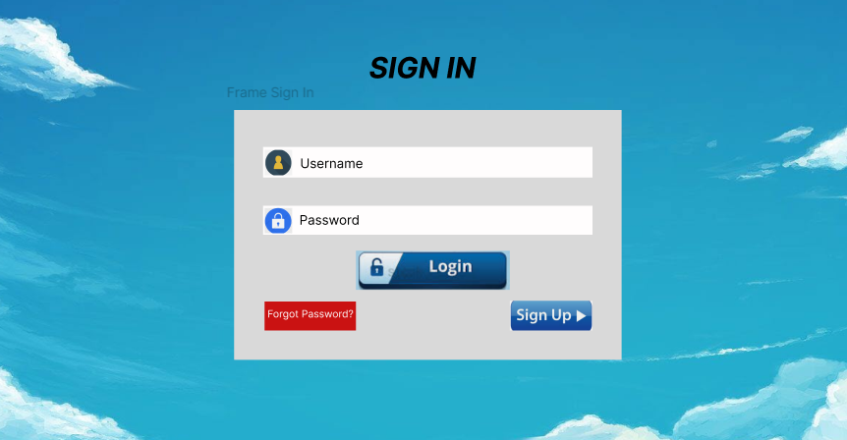

Description:

On the login screen, there will be 3 items that can be clicked to trigger a new page:

* Login: after filling in the account information and password

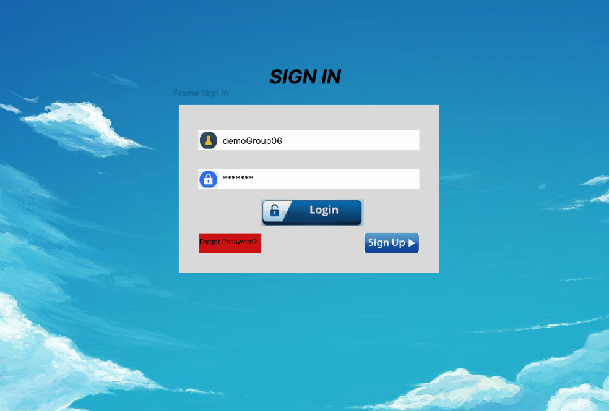

* + Here users can click on the Login button to proceed with logging into the system.
    - User successfully logged in:

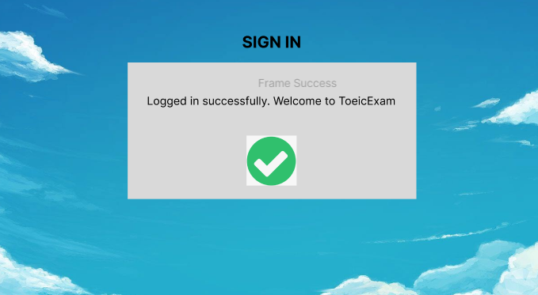

* + - User entered incorrect login information:

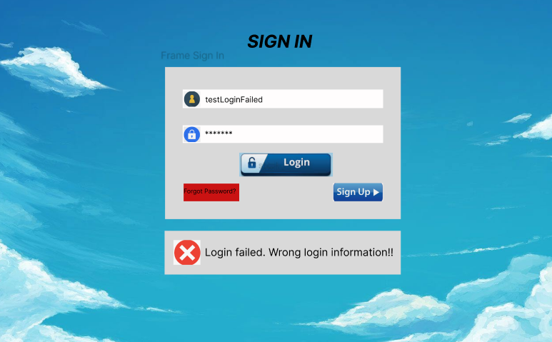

* Forgot Password?
  + First, the system will display a square for the user to enter the account name and search.

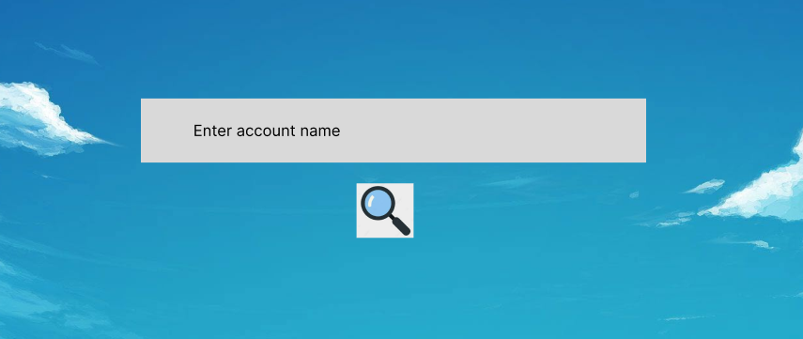

* + If the search is successful, the user will enter the registered phone number.



* + - Here. The user will be sent an OTP to the phone number. Enter the OTP and change the new password.

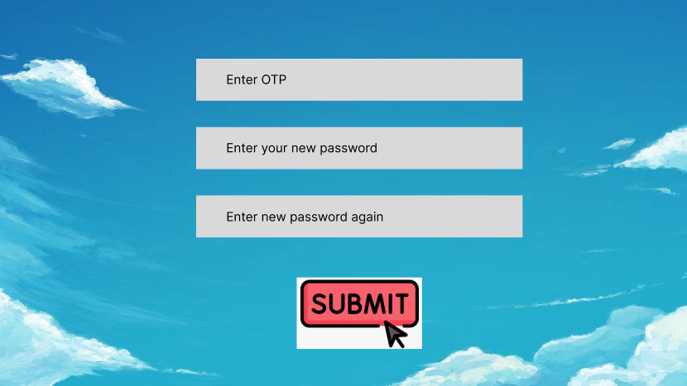

* + - If successful, the user will be returned to the main screen. Here. Users can enter the newly changed account and password to access the website.
    - If it fails, the system will notify that the user has not entered the correct OTP information or the password entered does not match.

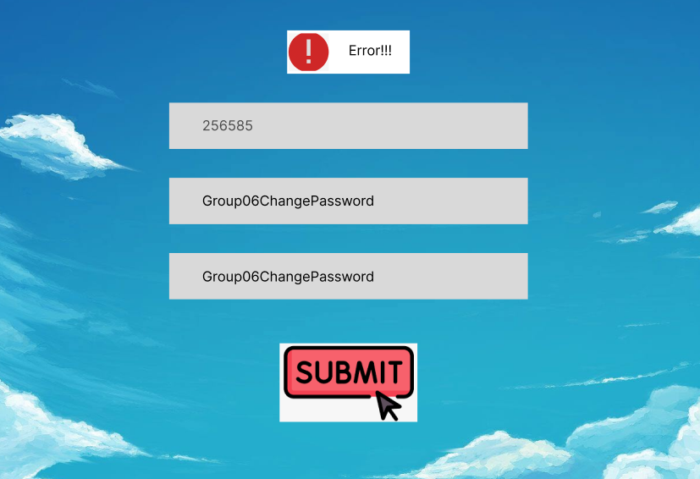

* + If the search fails, the system will say the account is not available.

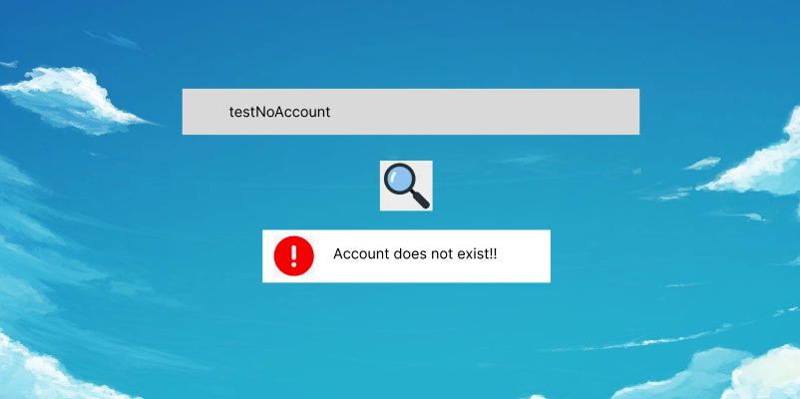

* Sign Up
  + Users will be asked to enter information including:
    - Account name
    - Password (password will be asked to re-enter once to confirm that the user entered the correct password)
    - Phone number

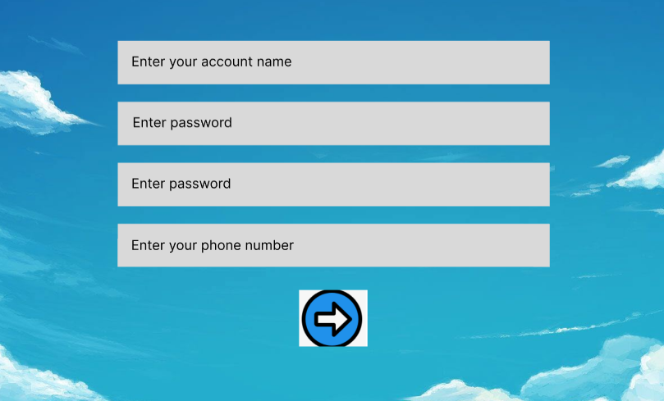

* + If the account or phone number is already in the system's data list. The system will report an error and ask the user to choose another name or phone number to register.
    - Register for an existing account:

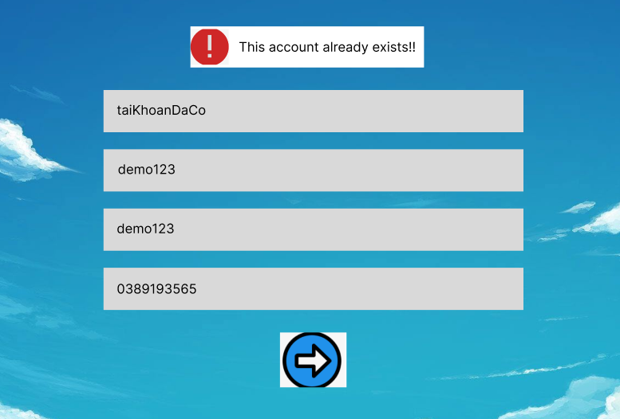

* + - Register with the phone number used to register for another account before:

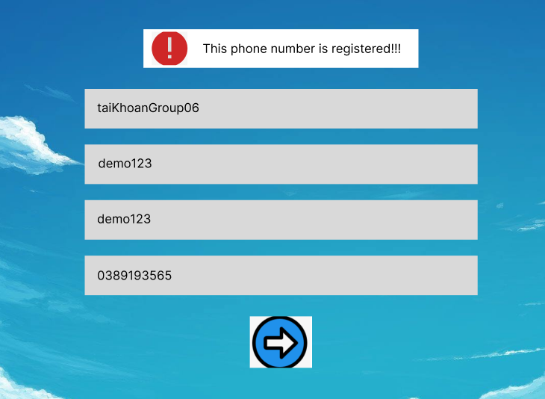

* + Then the user clicks on the arrow icon. The system will verify and send the OTP code to the registered phone number.

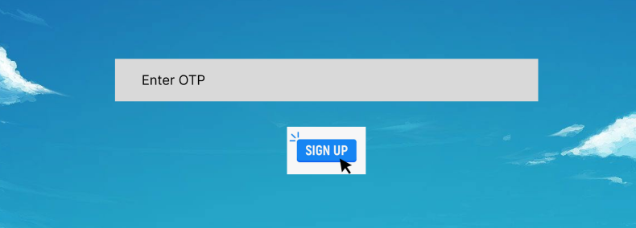

* + Sign up Success. The user will be returned to the login screen and begin to log in to the newly created account.

**Home page:**

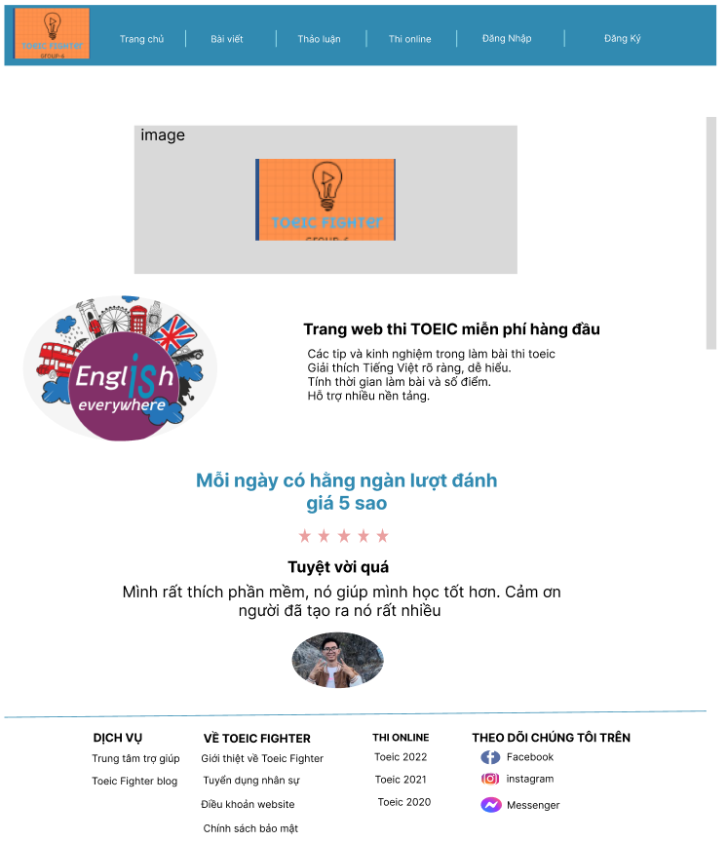

Description:

* When users enter the website to access the site, the screen will display as shown "homepage 1", including the web logo bar, the navigation menu bar to other parts of the web, if the user pulls down to the bottom then then Will display the images from "Home 2" to "Home 4" including: web page description, web comment, contact information of the web
* When users click on the "Trang chủ" section in the navigation bar, it will move to the picture "homepage 1"
* When the user clicks on the "Bài viết" section in the navigation bar

*For example, when clicking on the article on the navigation bar*

* When the user clicks on the "Thảo luận" section in the navigation bar, it will move to the

*For example, when clicking on the discussion on the navigation bar*

* When the user clicks on the "Thi online" section in the navigation bar, it will move to the following picture:

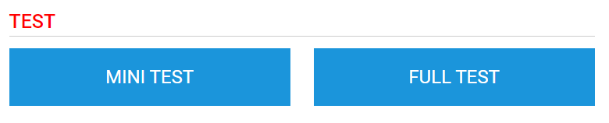

*For example, when clicking on the online exam*

* Người dùng sẽ chọn 1 trong 2 phần:
  + Nếu chọn Mini test thì màn hình sẽ hiển thị như sau:

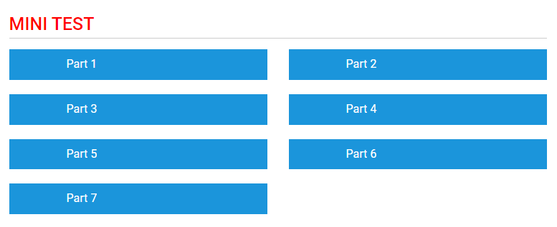

*For example when clicking on the mini test*

Users click on 1 of 7 parts to do, when clicking on Part 1 or Part 7, they will display the same as follows: (Details when clicking on will be presented below)

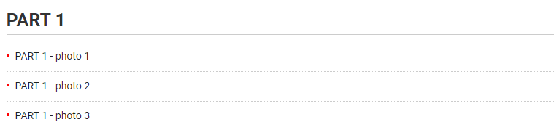

*For example when clicking on parts*

* If you choose full test, the screen will display as follows:

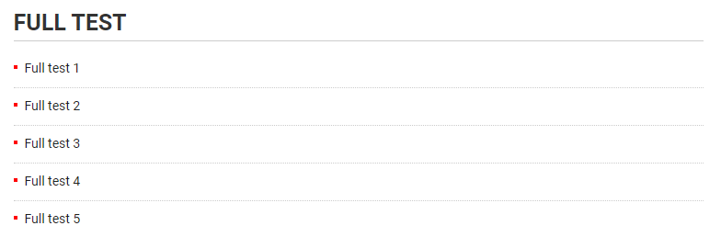

*For example when clicking on Full Test*

* Users click 1 of the full tests to do

**Part 1 Screen:**

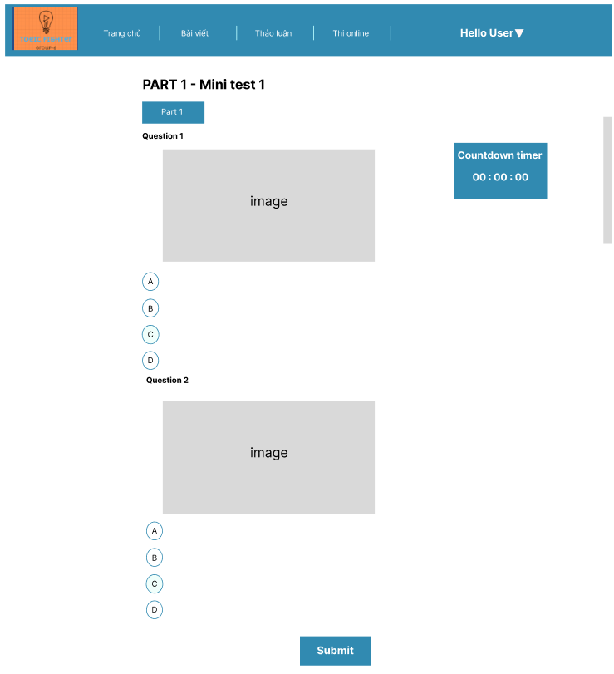

Description:

* When the user clicks on any part 1 test, it will display as above, including:
* Area 1:
  + Title part: Part 1 - Photo test 1
  + The Minitest button returns to the homepage
* Area 2:
  + Audio section to listen to users click to listen to English speaking
  + The user finished listening to select the answer of that question, the answer there was black
* Area 3:
  + Submit button to submit homework and automatic grading system
  + The meter counts down the test time, when the system is over, the system will automatically score

**Part 5 Screen:**

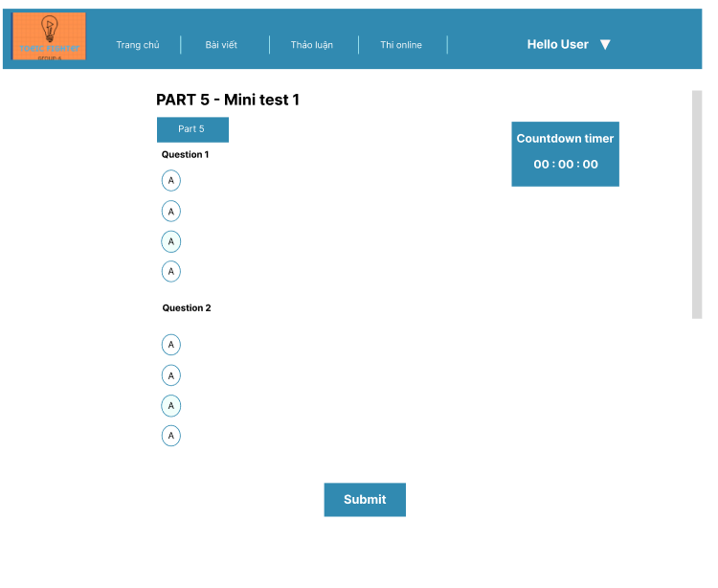

Description:

* When the user clicks on any test of PART 5, the interface will appear as above
* Area 1:
  + Part title: PART 5 - Incomplete Sentence - Test 1
  + Minitest button back to the previous page
  + The home button returns to the home page
* Area 2
  + The user section reads and chooses 4 answers below
  + If the user answers the question, it will be highlighted in bold
* Area 3:
  + Press the submit button, the system will display points as shown below
* Area 4:
  + Submit button for submission and grading system
  + A countdown timer for 14 minutes when the time is up, the system will score
  + If the user answers any question, that number box will be changed in color
  + Users can click on the sentence they want from 1 -> 30 to jump to